**SPRINT 2**

**REPORT**



**Author: Imangineers Team**

**Date:**

**Revision history**

|  |  |  |  |
| --- | --- | --- | --- |
| **Version** | **Date** | **Author** | **Notes** |
| **1.0** |  |  |  |
|  |  |  |  |
|  |  |  |  |

**TABLE OF CONTENT**

I. SPRINT 2- BACKLOG 4

II. SPRINT 2- BURNDOWN 4

III. SPRINT 2- CHECKLIST 5

IV. SPRINT 2 - SUMMARY 7

# SPRINT 2- BACKLOG

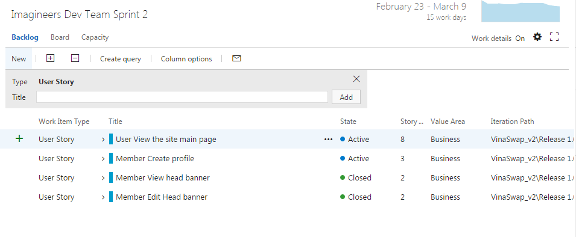

# SPRINT 2- BURNDOWN

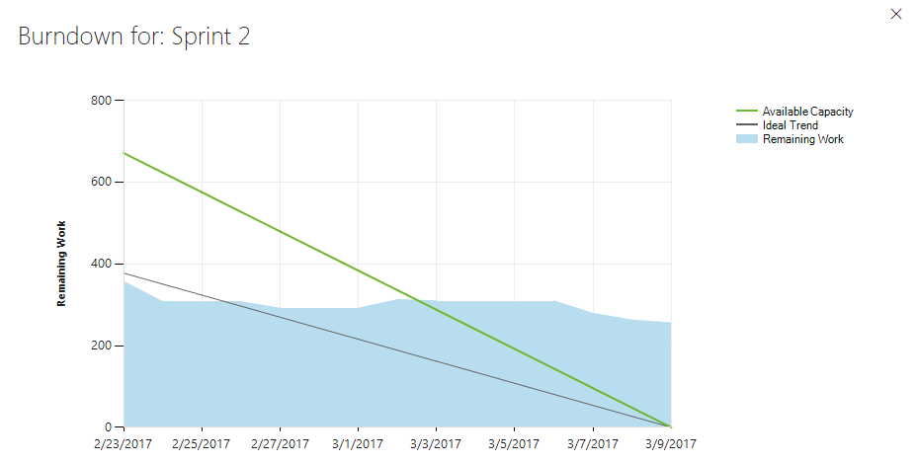

# SPRINT 2- CHECKLIST

|  |  |  |
| --- | --- | --- |
| Category | Detail | Status |
| User Story Clarity | User stories selected for the sprint are complete with respect to product theme, understood by the team, and have been validated by the detailed acceptance criteria. | All the stories are clear with acceptance criteria |
| Tasks Identified | Tasks for selected user stories have been identified and estimated by the team. - | All tasks have been identified with ID and estimated |
| Product owner approval | Each finished user story has been passed through UAT (User Acceptance Testing) and signed off as meeting requirements | Approved on  View introduction line  Edit introduction line |
| Updating Product Backlog | All features not done during the sprint are added back to the product backlog. All incidents/defects not handled during the sprint are added to the product backlog. | Backlog refined |
| Environment ready | Development environment is ready with all third-party tools configured.  Staging environment is ready.  Continuous integration framework is in place  Test data for the selected features has been created | Team service for task /backlog management  Coding and testing tools are well used |
| Design complete | Design analysis is complete as per the user story or theme.  Prototype have been created and approved by the respective stakeholders.  Use cases are developed | Prototype is approved by the customer  Use case is developed |
| Unit test cases written | Unit test cases have been written for the features to be developed | There are unit test cases |
| Documentation Ready | Documentation to support the sprint demo is ready | Documentation are well define |
| Code Complete | Source code changes are done for all the features in the “to do” list.” Source code has been commented appropriately. | Not complete on Create profile. There are still missing criteria |
| Unit testing is done | Unit test cases have been executed and are working successfully | Not done fully |
| Code Refactoring | Source code has been refactored to make it comprehensive, maintainable and, amenable to change. | In Github |
| Code checkin | Source code is checked in the code library with appropriate comments added. | Checked by Team dev |
| Code merging and tagging | Finalized source code has been merged with the main branch and tagged appropriately (merging and tagging guidelines are to be used) | Checked team dev |
| Project metrics are ready | Burndown chart has been updated regularly and is up to date. | There are burndown chart to track to progress |
| Functional testing done | Test team has reviewed and conducted necessary manual test cases to ensure that tests are passing. All incidents/defects are reported.  100% executed test cases and 80% test cases pass.  There are no major defect occurred  Accept 20% minor defects in layout or the defect doesn’t affect system | Running Functional test  There are some critical test case failed |
| Acceptance testing done | Each finished user story has been passed through UAT (User Acceptance Testing) and signed off as meeting requirements (see also Product Owner Approval). | Acceptance test approved on :  View head banner  Edit head banner  Not accept : Create profile due to missing some criteria |
| Closure | All finished user stories/tasks are marked complete/resolved. Remaining hours for task set to zero before closing the task. | Not done |

# SPRINT 2 - SUMMARY

* There are a lot of undone task leads to failure in done the stories
* The undone stories is sent back to the backlog for further development
* Team needs to fix this right away. If not it can cause the product to not finish on time